Basic definitions openalae:

It is a distributed collaborative effort to develop Python libraries and tools that address the needs of current and future works in Plant Architecture modeling. OpenAlea includes modules to analyse, visualize and model the functioning and growth of plant architecture.

dddf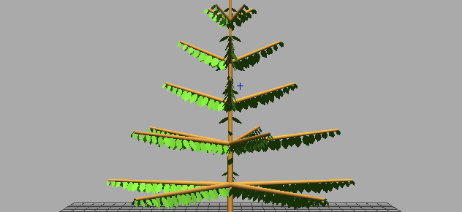dfdf

OpenAlea

Lpy

Openalea

Plant Scene

Multiscale tree graph

\

lpy2mtg,

mtg2lpy

Lpy

Multiscale tree graph

**Adel Wheat :**

Alinea.Adel (Architectural model of DEvelopment based on L-systems) allows to simulate the 3D architectural development of the shoot of gramineaous plant.

ADEL wheat’s

Wheat’s Architectural model generates sample weather, number ofplants, canopy, positioning of trees

It also has Lpy

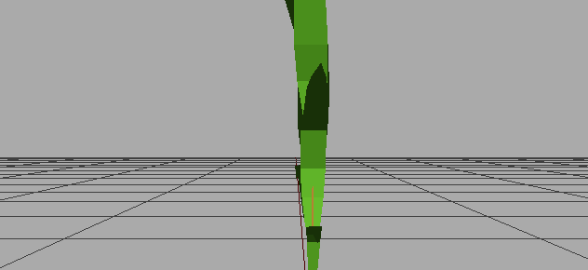

OpenAlea

Reads Lpy, provides a tool Plant Gl to view 3d Architecture of plant , interprets turtle commands

Refereces :

<http://openalea.gforge.inria.fr/dokuwiki/doku.php?id=openalea>

<https://www.researchgate.net/publication/230758120_ADEL-Wheat_a_3D_Architectural_Model_of_wheat_development>